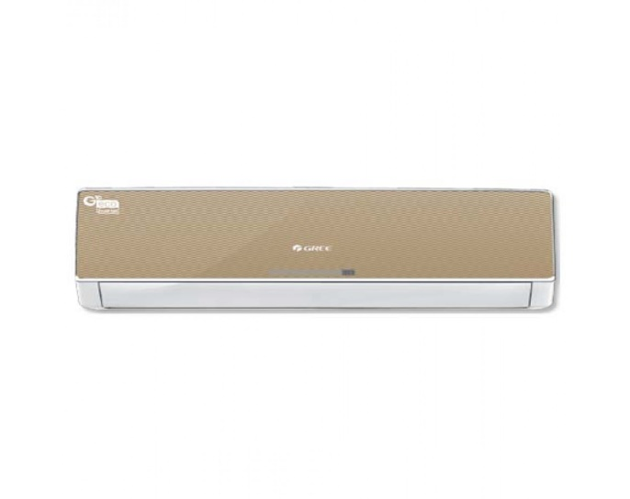

Weight | 70 kg
Air Conditioner Type | Wall Mounted Split
Cooling Type | Heat & Cool

