Harvel Electric
It is the best company which provides you the best electric appliances all over the world.

Our Products
Our products are geniune we import our products from malysia, nigerya, japan, indonesia, america & much more.

Claim Warranty
You can claim waranty at your nearest shop we provide our best make you satisfy for our products. Broken appliances will not be claimed.
Information Technology Solutions
Harvel-Electric
Life is easy with harvel
Harvel - Electric

LG – AC SK99M5

HSU1HNF

Key Features | FEATURES
- 65°C Dual Inverter Compressor™ | - Wall mounted split type air-conditioner
- 10 Year Warranty | - Inverter technology
- 60% Faster Cooling | - Heat & Cool
- 65% Energy Saving | - Stylish flat panel
- Comfort Sleep | - Heat and Cool
- Double Layer Condenser | - R-410A Eco Friendly
- .

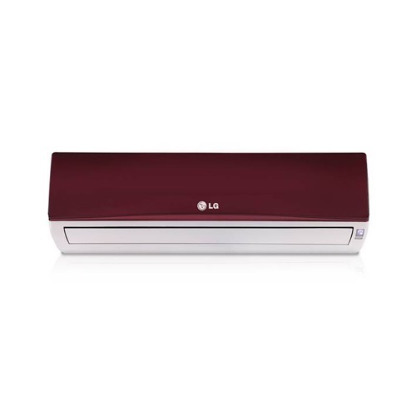

Weight |  | 55 kg
Technology |  | Inverter
Air Conditioner Type |  | Wall Mounted Split
Cooling Capacity |  | 2.0 Ton
Cooling Type |  | Heat & Cool
 | Weight | 70 kg

Fast Cooling & Energy Saving
Inverter Compressor constantly adjusts a compressor’s speed to maintain desired temperature levels. Moreover, Dual Inverter Compressor™ with power saving operation range frequency saves more energy than conventional compressor. Thanks to the Dual Inverter compressor, air is expelled farther and faster.

