Harvel Electric
It is the best company which provides you the best electric appliances all over the world.

Our Products
Our products are geniune we import our products from malysia, nigerya, japan, indonesia, america & much more.

Claim Warranty
You can claim waranty at your nearest shop we provide our best make you satisfy for our products. Broken appliances will not be claimed.
Information Technology Solutions
Harvel-Electric
Life is easy with harvel
Harvel - Electric

DAWLANCE – AC NHL18-HNF
HSU1HNF

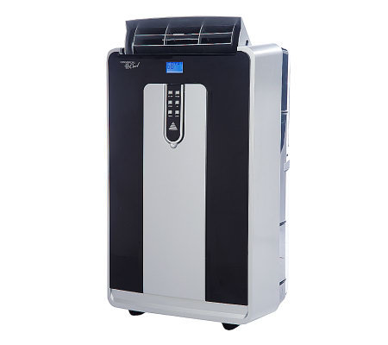

Brand | dawlance
Model ID | NHL18-HNF
Product Code | FAFHAIE5Y55
Type | portable AC
Capacity | 0.5 Ton
Energy Rating | 5 Star
Inverter AC | No
- .

Weight | 40 kg
Cooling Type | Cooling only
Cooling Capacity | 0.5 Ton
Technology | Conventional
Air Conditioner Type | portable AC

There NHL18-HNF is the AC you should probably get, especially if it’s for an office, den, or other room where you won’t be sleeping. For some people, it’ll be fine in a bedroom, too. It’s widely available and the price is fair, so you shouldn’t have any trouble finding it on short notice

