Harvel Electric
It is the best company which provides you the best electric appliances all over the world.

Our Products
Our products are geniune we import our products from malysia, nigerya, japan, indonesia, america & much more.

Claim Warranty
You can claim waranty at your nearest shop we provide our best make you satisfy for our products. Broken appliances will not be claimed.
Information Technology Solutions
Harvel-Electric
Life is easy with harvel
Harvel - Electric

DAWLANCE – AC HSY18-9FL
HSU1HNF

Brand | dawlance
Model ID | HSY18-9FL
Product Code | LAFHAIE5Y55
Type | SPLIT AC
Capacity | 2 Ton
Energy Rating | 5 Star
Inverter AC | No
- .

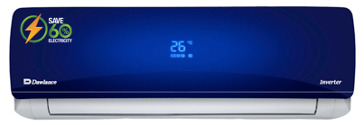

Weight | 75 kg
Cooling Type | Cooling only
Cooling Capacity | 2 Ton
Technology | Conventional
Air Conditioner Type | SPLIT AC

Most air conditioners are loud, but the HSY18-9FL is the least-worst of the $250-ish, 8,000 Btu ACs. It’s a bit quieter overall and sounds lower-pitched. At its absolute loudest, with the compressor on and the fan at full speed, we measured it running at 66 dBC (that is the C-weighted decibel scale).

