Harvel Electric
It is the best company which provides you the best electric appliances all over the world.

Our Products
Our products are geniune we import our products from malysia, nigerya, japan, indonesia, america & much more.

Claim Warranty
You can claim waranty at your nearest shop we provide our best make you satisfy for our products. Broken appliances will not be claimed.
Information Technology Solutions
Harvel-Electric
Life is easy with harvel
Harvel - Electric

DAWLANCE – AC FGRQ08L3T1
HSU1HNF

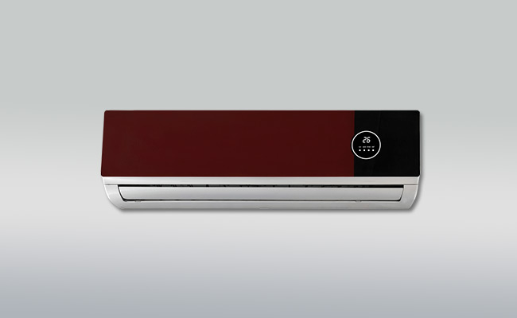

Brand | dawlance
Model ID | FGRQ08L3T1
Product Code | LAFHAIE5Y52
Type | SPLIT AC
Capacity | 1 Ton
Energy Rating | 5 Star
Inverter AC | No
- .

Weight | 60 kg
Cooling Type | Cooling only
Cooling Capacity | 1 Ton
Technology | Conventional
Air Conditioner Type | SPLIT AC

If you’re installing an air conditioner in your bedroom, or if you just value peace and quiet in any other room, treat yourself to the (relatively) hushed performance of the Frigidaire Gallery FGRQ08L3T1. It usually costs $50 to $80 more than our main pick or our runner-up, but it runs very quietly, and you’ll sleep better all summer.

