Harvel Electric
It is the best company which provides you the best electric appliances all over the world.

Our Products
Our products are geniune we import our products from malysia, nigerya, japan, indonesia, america & much more.

Claim Warranty
You can claim waranty at your nearest shop we provide our best make you satisfy for our products. Broken appliances will not be claimed.
Information Technology Solutions
Harvel-Electric
Life is easy with harvel
Harvel - Electric

DAWLANCE – AC FGRQ08L3T1
HSU1HNF

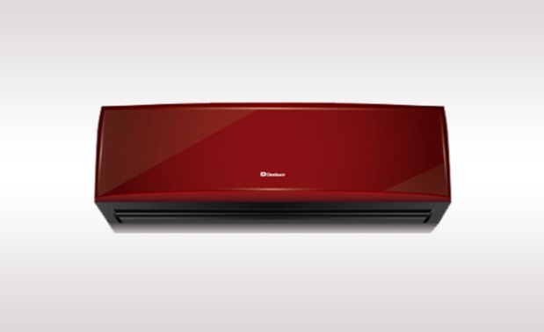

Brand | dawlance
Model ID | GRQ09ln8
Product Code | LAFfAIE5Y52
Type | SPLIT AC
Capacity | 1.5 Ton
Energy Rating | 5 Star
Inverter AC | No
- .

Key Features

Low voltage start up technology- runs perfectly on low voltage (155V).

3 mode operation: sleep mode, soft dry operation mode, cool mode

Auto restart function

Turbo-mode for quick cooling

Voltage fluctuations and power shutdowns have become a daily occurrence. Our LVS air-conditioner helps you protect your appliances from heavy voltage fluctuations. Its smart technology is capable of operating at as low as 155V and saves you additional costs of buying stabilizers.

