Harvel Electric
It is the best company which provides you the best electric appliances all over the world.

Our Products
Our products are geniune we import our products from malysia, nigerya, japan, indonesia, america & much more.

Claim Warranty
You can claim waranty at your nearest shop we provide our best make you satisfy for our products. Broken appliances will not be claimed.
Information Technology Solutions
Harvel-Electric
Life is easy with harvel
Harvel - Electric

ORIENT – AC FGRQS005D
HSU1HNF

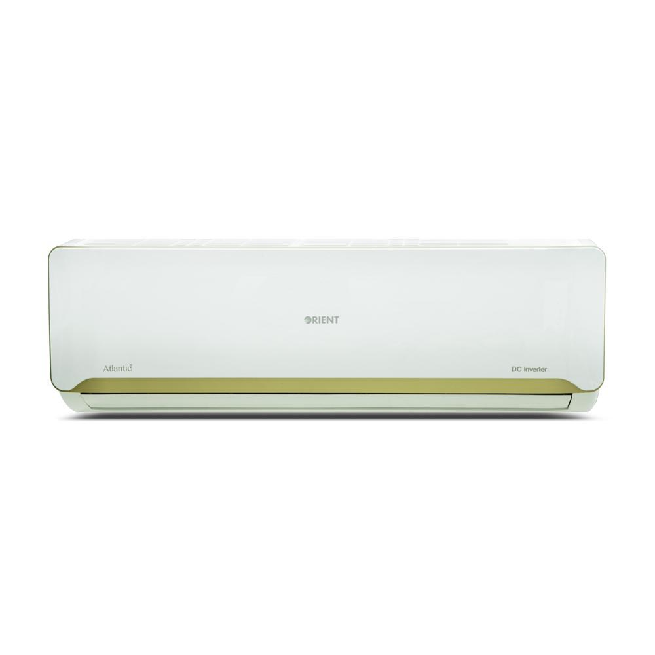

Brand | orient
Model ID | ATLANTIC DC  INVENTER
Type | SPLIT AC
Capacity | 1.5 Ton
Energy Rating | 5 Star
Inverter AC | No
- .

Electrical Data
RATED VOLTAGE 220-240V | 220-240V
RATED FREQUENCY 1PH,50HZ | 1PH, 50HZ

Cooling
RATED CAPACITY (COOLING) 18000BTU/H | 18000 Btu/h
RATED POWER CONSUMPTION (C) 1650W | 1650 W
RUNNING CURRENT (C) 7.2A | 7.2 A
SEER (C) 3.6 | 3.6

The inverter technology based 1.5 Ton Atlantic DC Inverter AC not only offers efficient cooling performance under all weather conditions but draws minimum energy enabling you to enjoy reduction of bills by up to 50%. Atlantic’s elegant design is centered on enhancing the overall look of your dwelling and its eco-friendly R410A refrigerant ensures optimum cooling results while keeping the environment safe.

