Harvel Electric
It is the best company which provides you the best electric appliances all over the world.

Our Products
Our products are geniune we import our products from malysia, nigerya, japan, indonesia, america & much more.

Claim Warranty
You can claim waranty at your nearest shop we provide our best make you satisfy for our products. Broken appliances will not be claimed.
Information Technology Solutions

Key Features
AddWash
Bubble Soak
Bubble technology
Child Lock
IRON-ROWENTA-RO-6043
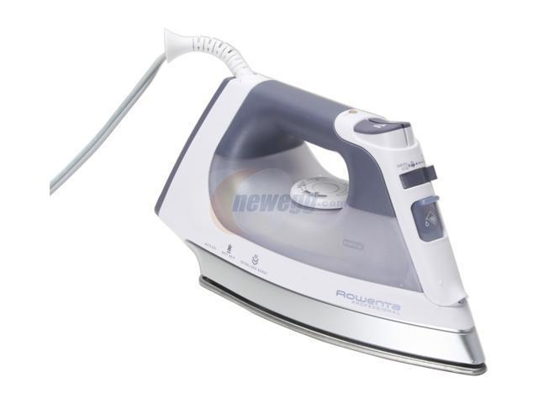
Delay End
Diamond Drum
Last Memory
Inverter Motor
Quick Wash
Smart Check
Spin Speed 1400 rpm
Super SpeedSmartphone App
Features
- Easy and Stable Glide
- Easy to Grip, Ergonomic Handle
- Anti-Calcium
- Desalting Performance
- Anti-Deposition System
- Separate Button for Water Spray
- Barefoot
- Steam Hole System
- Self Cleaning (Forced Drainage)
- Steaming the Moment
- Heavy Duty Design for Comfortable Ironing
- Big Soleplate, Quick Result
- Jet Steam Vertical Vapor Shock System
- Volume Setting
- Water Tank
- 360 Degree Scratch Pad – Alumite
- Precision Tip
- Anti-Drip System
- Vertical Steam
- Easy Maintenance & Long-lasting
- U-Shape Form
- Ceramic Coating
- Durable
- Easy Operation
- Alumite Shoe Material
- Made in Japan

Weight  5 KG | 20 kg
Brands  ROWENTA | Panasonic
Electronics Type  IRON | Iron

 | Power |  | 400W
 | Weight |  | 20 kg
 | Power |  | 920W
Weight

The Smarter, Quietest Clean.
LG Hom-Bot is a truly intelligent robotic vacuum with wi-fi capabilities, giving users total control using a smartphone. And while Hom-Bot’s cleaning technology makes people take notice, thanks to an innovative design that absorbs vibrations and reduces noise, it’s the quietest robot vacuum on the market on non-carpeted floors.* |  | C onventional
The Smarter, Quietest Clean. |  | Wall Mounted Split

Harvel-Electric
Life is easy with harvel
Harvel - Electric

