Harvel Electric
It is the best company which provides you the best electric appliances all over the world.

Our Products
Our products are geniune we import our products from malysia, nigerya, japan, indonesia, america & much more.

Claim Warranty
You can claim waranty at your nearest shop we provide our best make you satisfy for our products. Broken appliances will not be claimed.
Information Technology Solutions

Key Features
AddWash
Bubble Soak
Bubble technology
Child Lock
JUCIER MACHINE-PANASONIC-MJ-J12jp
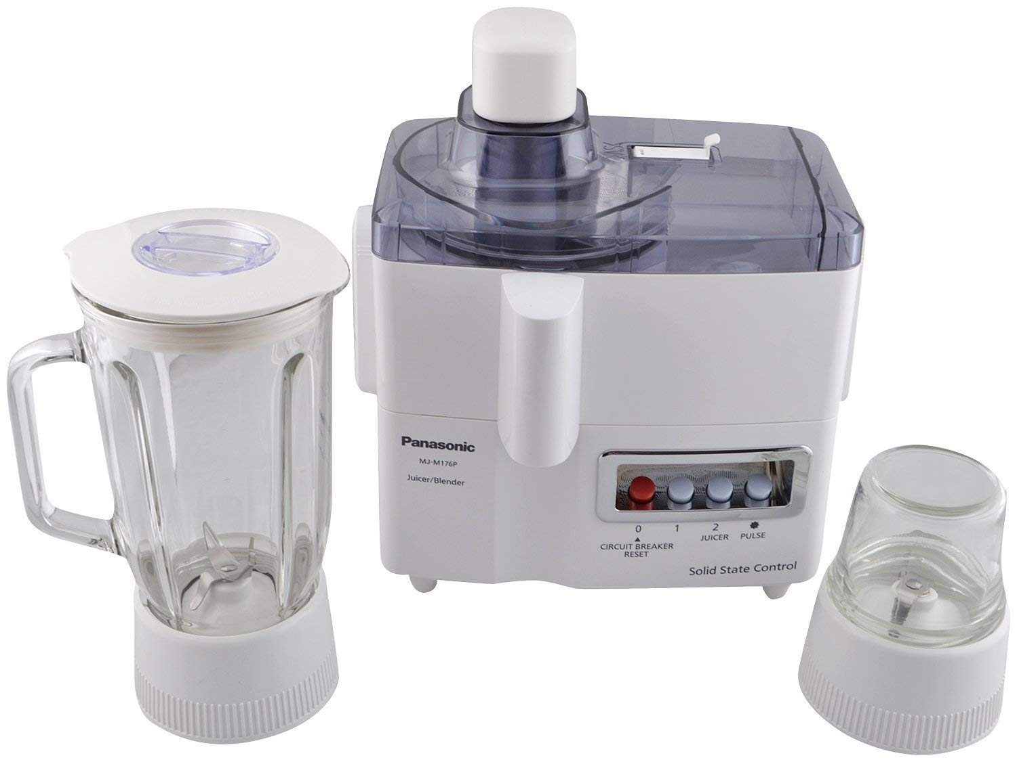
Delay End
Diamond Drum
Last Memory
Inverter Motor
Quick Wash
Smart Check
Spin Speed 1400 rpm
- Juicer Blender:
- 3-in-1 Functions (Juicer/Blender/Mill). Full Metal Stainless Steel Spinner. Titanium Saber Cutter. Self-Ventilating Inner Cap. Built-In Circuit Breaker. Clear Glass Container.
- Full Metal Stainless Steel Spinner:
- Because it is made entirely of stainless steel,it can rotate at high speed to extract more juice than ever before. The metal design also means there is minimal clogging and nicking of blades so they stay sharp longer.

Super SpeedSmartphone App
Base | Dry
Capacity | 50 g
Material | Glass
Cutter Material | Titanium  Coated  Cutter
Power Control | 2 Speed  + Pulse
Switch Type | Piano
Juicer | Yes
Blender Safety Lock | Yes
Circuit Breaker | Yes

 | Power |  | 400W
 | Weight |  | 20 kg
 | Power |  | 920W
Weight

The Smarter, Quietest Clean.
LG Hom-Bot is a truly intelligent robotic vacuum with wi-fi capabilities, giving users total control using a smartphone. And while Hom-Bot’s cleaning technology makes people take notice, thanks to an innovative design that absorbs vibrations and reduces noise, it’s the quietest robot vacuum on the market on non-carpeted floors.* |  | C onventional
The Smarter, Quietest Clean. |  | Wall Mounted Split

Harvel - Electric

Harvel-Electric
Life is easy with harvel

